Steps before pulling together the audit document
- Review the website
Familiarise yourself with the brand’s offerings, screenshot all data-capture forms and sign up (check whether you get a welcome email), check whether a loyalty program and/or subscription exists, and test the abandoned cart flow by adding a product to cart and proceeding to checkout (confirm whether the site is on Shopify).
- Review the Klaviyo account
Get a high-level understanding of their flow suite, campaign cadence & segmentation, revenue performance, and connected tech integrations.
- Prepare the audit template
Locate the most recent audit template from the same industry and create a copy to use as the foundation for this audit.

Section 1: KAV

- Go to Dashboard → Business Review. Set the time period to Year-to-Date, or use the last 12 months when conducting an audit early in the year.

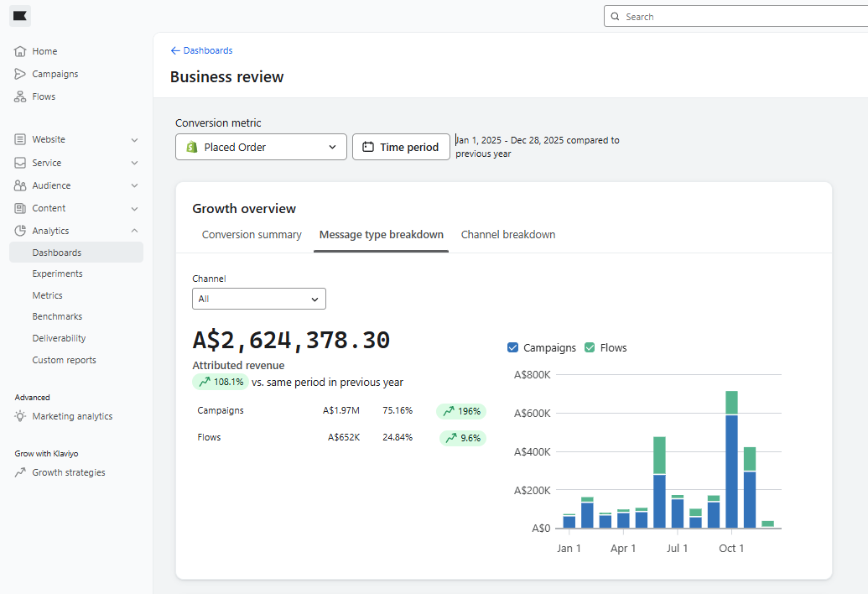

- From the Business Review dashboard, copy the required KAV metrics into the table below so all data lives in one place. When requesting AI insights, include a screenshot of this completed table.

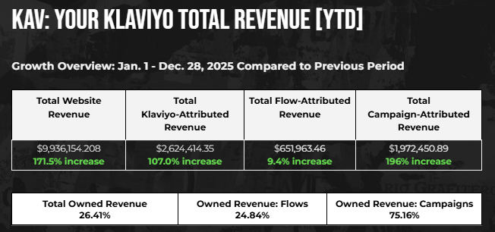

- Take a screenshot of this table and share it with AI. When writing your prompt, copy the KAV insights from the previous audit template and ask AI to structure the insights in the same way, tailored to the current brand’s performance using the screenshot as context.

“Can you give insights on [Brand Name]’s KAV. Structure it similar to this but make it relevant to their performance (attached).”

- Repeat the same prompt structure for the remaining insights, using the previous template as a reference.

- Campaigns vs. Flows
- Email vs. SMS
- Growing Your KAV

Section 2: List Growth

- Go to Profiles → View Subscriber Growth. Go to Email and set the Date Range to YTD Monthly.

Screenshots needed (examples below):

- Growth Graph
- Opt-in sources
- Exclusion sources

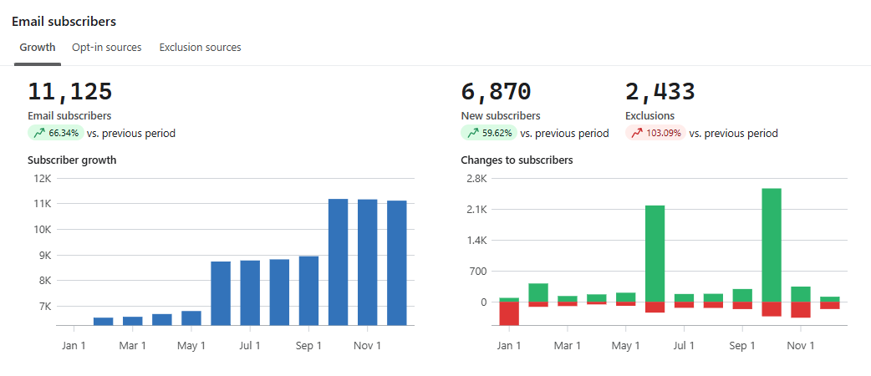

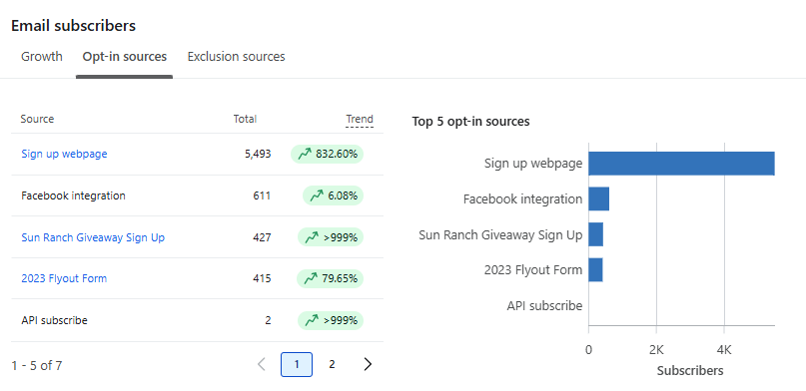

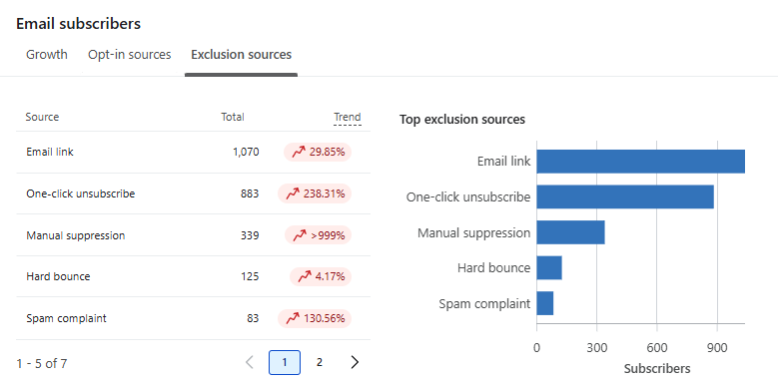

- Copy the List Growth insights from the previous audit and prompt AI to structure the insights in the same way, using the data from the screenshots to inform the analysis. Attach all three screenshots when sending the prompt to AI.

“Can you give insights on [Brand Name]’s List Growth. Structure it similar to this but make it relevant to their performance (attached).”

- Repeat for SMS.

Section 3: List Engagement

- Go to List & Segments → create an All Active Profiles segment.

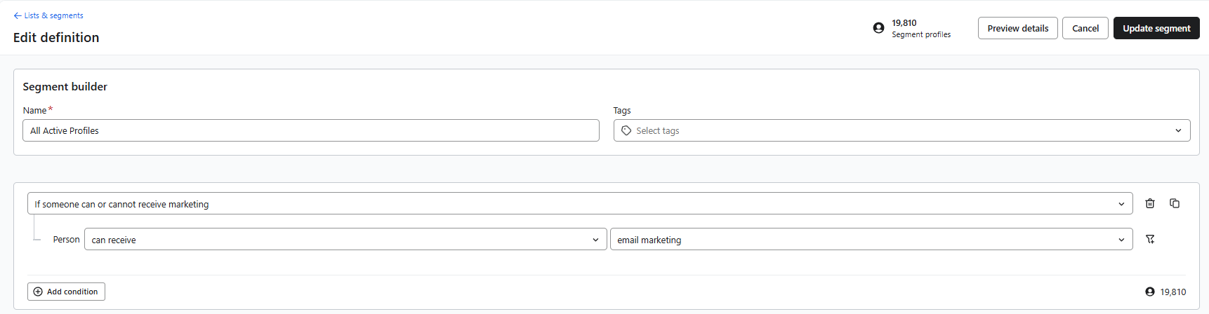

- After building the segment, review the Engagement view and convert the line-graph data into percentages for the audit table. Percentages can be calculated using https://percentagecalculator.net/.

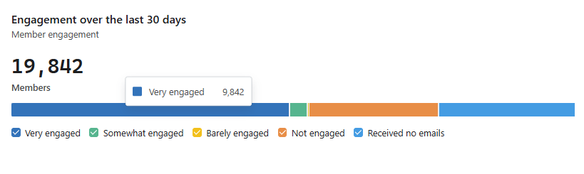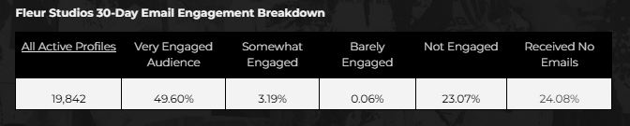

- Take a screenshot of the table and include it with your AI prompt. Reference the insights from the previous audit to guide the analysis.
“Can you create insights on [Brand Name]’s List Engagement Breakdown? A healthy email list should have more than 50% of members in the "Very Engaged" or "Somewhat Engaged" categories, with no more than 25% categories ed as "Not Engaged." Structure the insights similar to the one below but make it relevant to [Brand Name]’s data (attached).”

Section 4: Data Capture

- Go to Website → Sign-up Forms. Select each form and, from the dashboard, transfer the required data into the audit table. Repeat this process for all relevant live forms.

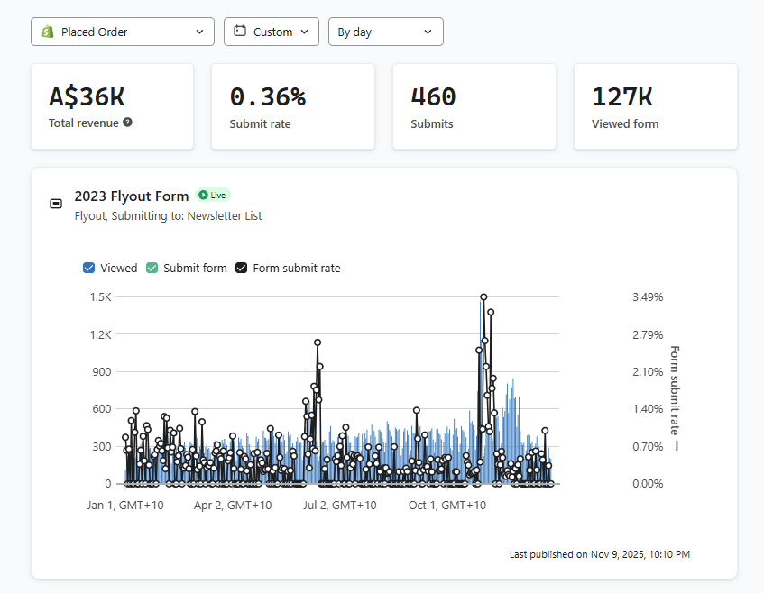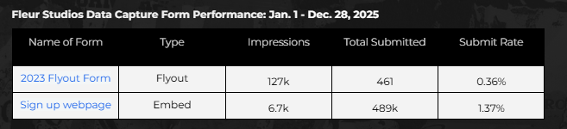

- Take a screenshot of the table and send it to AI along with the insights from the last audit. Use these to create the prompt:

“Can you create insights on [Brand Name]’s Data Capture Performance? The typical benchmark across industries is between 3-6%. Structure the insights similar to the one below but make it relevant to [Brand Name]’s data (attached).”

- For Areas of Opportunity, review the form targeting and behaviour, the incentive being offered, and document your observations. Share these observations with AI and create a prompt to refine and improve the recommendations. Attach best-practice examples from past work for reference.

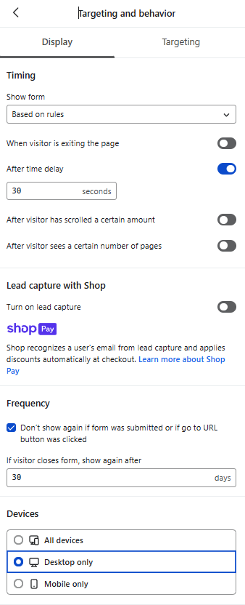

Section 5: Flows

- Go to Custom Reports → Create from scratch → Report Type: Flow Performance Report

Data needed:

- Email Recipients
- Email Open Rate
- Email Click Rate
- Placed Order Rate
- Placed Order Value SUM
- Group by: Flow
- Timeframe: YTD

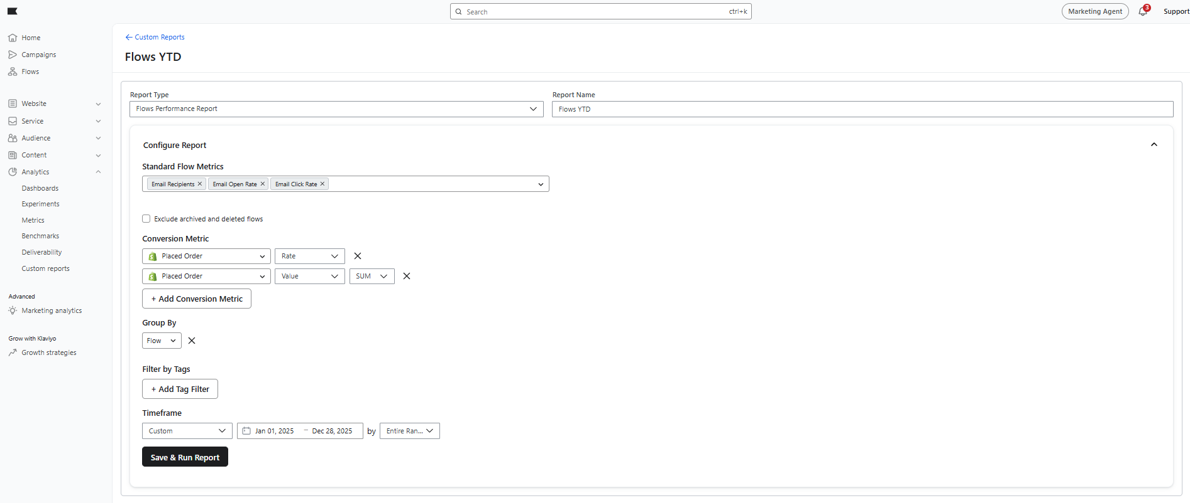

- Copy each flow’s data into its own dedicated table within the audit.

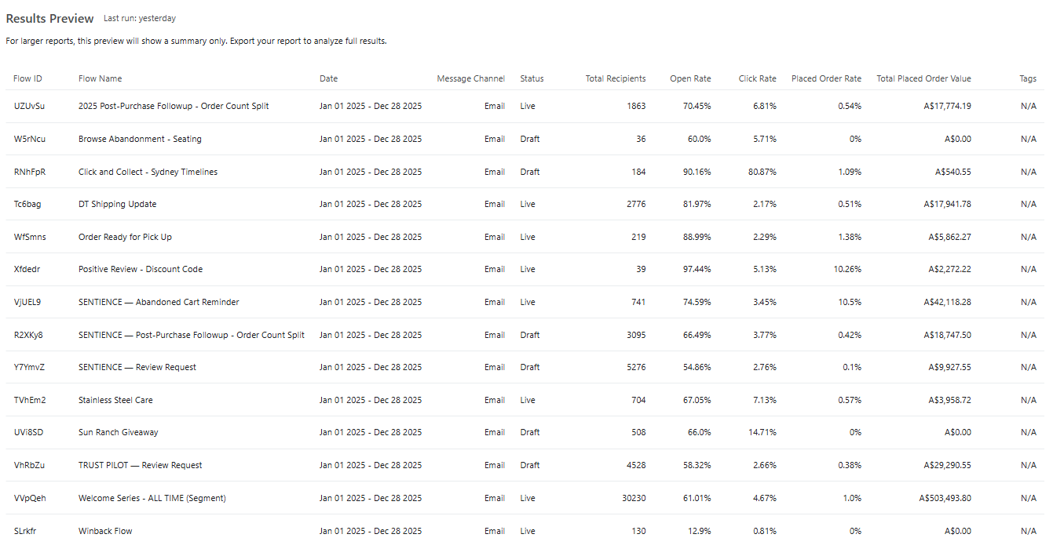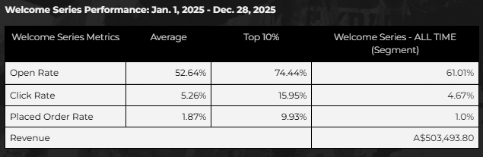

- Industry benchmarks can be found in this excel file or in this page.

- Recommendations for optimising each flow are based on a review of the flow structure, logic, and individual email content.

Section 6: Campaigns

- Go to Analytics → Benchmarks → Campaigns. Set time period to YTD.

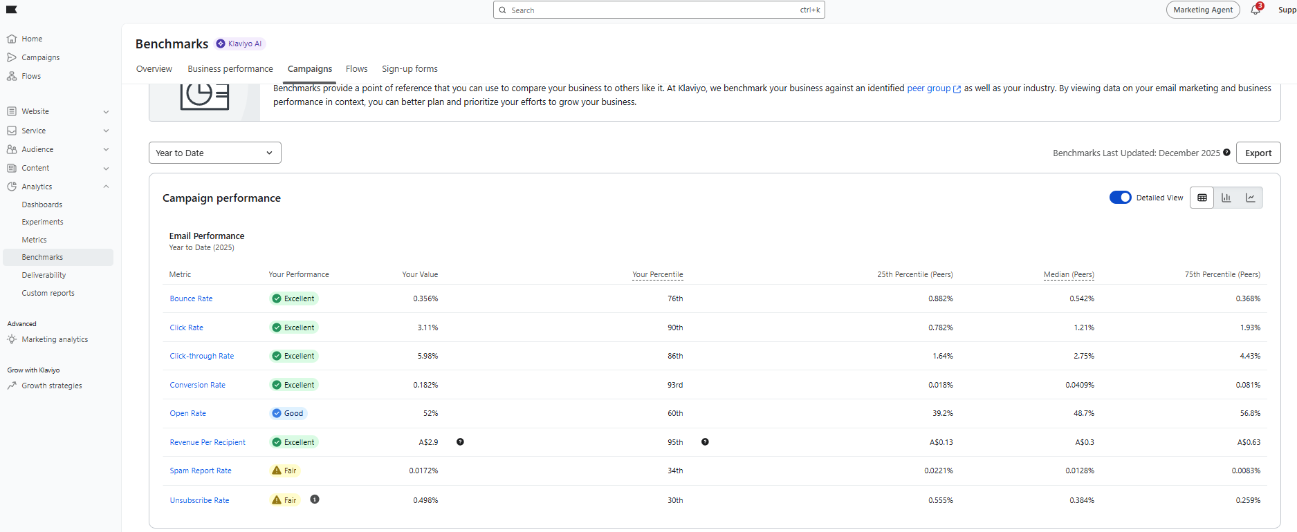

- Take a screenshot of the Campaign Performance section and send it to AI along with the previous audit’s insights. Instruct AI to follow a similar structure while tailoring the analysis to [Brand Name]’s performance shown in the screenshot.

- If deliverability is critical, go to Analytics → Deliverability → Reports, then send the data to AI with your observations and draft recommendations for refinement.

Example ChatGpt Prompts here for the Fleur Studios audit:
https://chatgpt.com/share/6956f52c-0218-800d-9086-b3bd69054e5a

